Global Tech Salary 2020-2024

# Final Report Introduction

The technology sector is witnessing rapid growth and continuous development, making it one of the most attractive sectors for graduates and job seekers. In light of this intense competition for technical competencies, the issue of technology job salaries has become of great importance. This report aims to shed light on technology job salaries around the world, and provide a comprehensive and detailed analysis of the most important factors that influence determining these salaries.

The importance of this report lies in its being a comprehensive and reliable reference for those interested in the technology sector, whether they are new graduates looking for job opportunities, professionals seeking to develop their careers, or technology companies seeking to understand the labor market and determine competitive salaries. This report can also benefit researchers and academics interested in studying the technology labor market and analyzing global trends in this field

# Business Impact

The analysis of the **GLOBAL TECH SALARY 2020-2024** dataset could help businesses to:

**• Help companies design competitive salary structures.**

**• Empower employees to understand their market value.**

**• Provide insights into the impact of remote work on global salary trends.**

# In general, the analysis of the global technology salary data set can have a significant impact on businesses, whether for fresh graduates or experienced technologists, by understanding their value in the job market and helping them find the best options available in the market in terms of the type of employment and the method of employment, whether remote or on-site, taking into account the size of the companies that meet their ambitions, or at the company level, so that through this analysis, companies can restructure salaries and offer more flexibility in order to attract the expertise and talents available in the job market, based on the aspirations of those companies, their budgets and their ability to contain those expertise.

# Data

Dataset Name: global_tech_salary.txt

Description: This dataset shows technology job salaries and factors such as

employment type, company size and Experience level.

**Data Details**: 5000 Rows & 11 Columns

**Size**: 238 KB

Source: [Kaggle](https://www.kaggle.com/datasets/yaaryiitturan/global-tech-salary-dataset?select=global_tech_salary.txt)

# Data Analysis & Computation

## Data Profiling:

* **Convert text to columns using Ecxel**
* Apply Excel filter to the dataset.
* Examine each attribute's unique value for inconsistency.
* Notable Features
  + 123 Unique Job_title
  + 5 Unique Years
  + 4 Unique experience_level
  + 3 type of company_size ( large – medium – small)
  + employment_type : (CT: ‘Contract’), (FT: ‘Full-Time’), (PT: ‘Part-Time’), ( FL: ‘Freelance’)
  + number of company_location : 55 location
  + The percentage of remote work : (0 : One-site , 50: Hybrid, 100: Fully Remote)
  + The salary currency type was entered by local currencies, and those values were converted to USD .
* **Data Wrangling:**

**The data was processed using Excel.**

**The cleaning process included validating the data, removing duplicates, standardizing date formats, and correcting spelling errors in column names.**

**It was ensured that all values in numeric columns were valid numbers, and that the text data was consistent.**

**After the cleaning process was completed, the data was exported to CSV format for use in subsequent analyses.**

* **Dataset Table Schema:**

|  |  |  |
| --- | --- | --- |
| * **Field** | * **Type** | * **Description** |
| * **Work_year: The year the salary data was collected** | * Integer | * Years analyzed salary data from 2020 to 2024 |
| * **Experience_level: The experience level of the employee** | * Text | * Experience levels EN(Entry-level), EX(Executive-level), MI(Mid-level), SE(Senior-level) |
| * **Employment_type: The type of employment contract** | * Text | * Types of employment that are divided into FT(Full-time), PT(Part-time), CT(Contract), FL(Freelance) |
| * **Job_title: The title of the job** | * Text | * It contains (123) job titles over years, as many new titles have emerged over the years |
| * **Salary: Salary in the specified currency** | * Numeric | * The local currency of each country as companies are located in different locations around the world |
| * **Salary_currency:** **The currency of the salary** | * Text | * Local currency code |
| * **Salary_in_usd: The salary converted to USD for comparison** | * Numeric | * Salary value in USD |
| * **employee_residence: The primary country of residence of the employee** | * Text | * Employee’s primary country |
| * **remote_ratio: The percentage of remote work (0: On-site, 50: Hybrid, 100: Fully Remote)** | * Integer | * Remote work rate |
| * **company_location: The country where the company is located** | * Text | * Company locations around the world |
| * **company_size: Size of the company (S: Small, M: medium , L: Large)** | * Text | * Companies size |

# **Exploratory Data Analysis (EDA):**

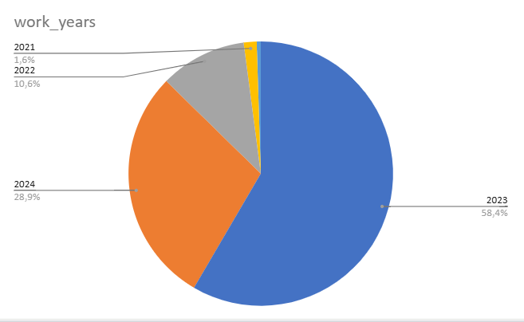

**1 – Work Year :** As is clear, technology job salaries have increased significantly over the years. Comparing the percentage, we find that in 2021 the percentage was 1.6% of the total five years, in 2022 it reached 10.6%, and the largest percentage was in 2023, reaching 58.4%. In 2024 (up to the date of global data collection), the percentage of the total five years was 28.9%. This decrease from 2023 is due to several possible reasons, including that the data set did not include the entire year 2024, or that it is due to the merger of some jobs or a change in roles. As we will notice in the dashboard, there are some job titles that were not in 2020 and 2021, but were created in subsequent years, which makes this analysis important for monitoring the development of technology jobs and its impact on employee salaries in this field.

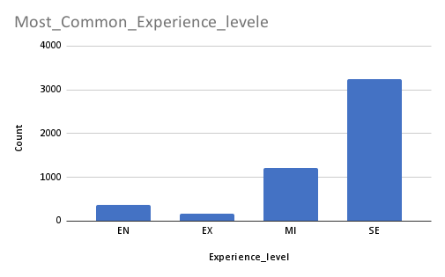

**2- Most Common Experience Level:**

This chart is expected to show an increase in demand for **senior** and **mid-level** employees over the years, which confirms the need for graduates to develop their skills and expertise, and encourages companies to benefit from new talents by developing training programs that increase individuals’ expertise to meet the needs of the labor market.

**3- Salaries :**

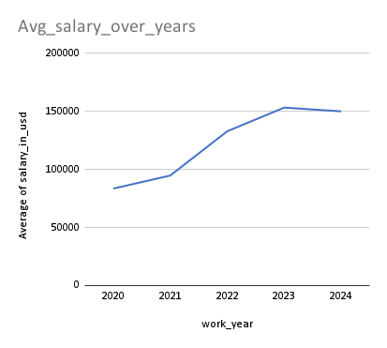

- The overall trend of the graph indicates a steady growth in average salaries in the technology sector during the period from 2020 to 2024.

- This growth reflects the increasing demand for technology skills, and the increasing importance of technology in the global economy.

- Technology companies must take these trends into account when determining their employees’ salaries, in order to remain competitive in the job market.

- Tech workers must keep up with the latest technological developments, and stay up to date with the skills required in the job market.

## 

## **4- Most Common Job Titles**: The chart shows that there are several key job titles that dominate the tech job market:

## - Data Engineer: This is the most common job title, appearing 1,067 times.

## - Data Scientist: This comes in second place, appearing 1,025 times.

## - Data Analyst: This comes in third place, appearing 735 times.

## - Machine Learning Engineer: This comes in fourth place, appearing 511 times. Of the 123 job titles, it is clear that a number of roles have dominated the market over the years.

## - Specialized Job Titles: The chart also shows that specialized job titles such as “Research Scientist” are less common, indicating that the tech job market is largely focused on applied and practical roles.

## - Job Title Distribution: The chart shows that there is a wide variety of job titles in the technology sector, with 123 job titles. However, the majority of jobs are concentrated in highly visible job titles.

**Challenges and Solutions:**

some challenges emerged during this analysis journey that are expected to be of great importance to all parties related to technology jobs, from individuals and companies to policy makers and decision makers. With the development in the field of technology, the demand for jobs has increased and there have been major changes in salaries over the years, and the experiences and job titles have diversified, reaching 123 job titles, which requires conducting a study of each job title and the reason for the increase in demand for it and the impact of experience, type of employment and its form on salaries for that title. I found that highlighting the most in-demand job titles may largely clarify the purpose of this analysis, without neglecting to show all the less common job titles that will later appear in detail in the interactive dashboard.

**Description of Dashboard And Dashboard Link:**

**Dashboard link** [**DASHBOARD**](https://public.tableau.com/views/TechSalaryInsightsDashboard/Story1?:language=en-US&:sid=&:redirect=auth&:display_count=n&:origin=viz_share_link)

**-** An advanced interactive dashboard is designed to enable users to comprehensively explore and analyze global technology job salary trends. This dashboard provides valuable insights into the developments in the technology job market, helping researchers, graduates, and companies make informed decisions.

**Key Features:**

- Annual Salary Average Analysis:

- The dashboard allows users to view salary averages for each year, providing an accurate view of annual wage changes.

- Users can compare salary averages across years to identify long-term trends in the job market.

**Hiring Trend Analysis:**

- The dashboard provides data on various hiring trends, including remote work, on-site work, and hybrid work.

- Users can select the type of employment that best suits their needs and preferences, whether they are job seekers or recruiters.

**Salary and Demand Influencer Analysis:**

- The dashboard provides a detailed analysis of the factors that influence salaries and job demand, such as experience levels, company locations, and company sizes.

- Users can identify the factors that influence their potential salaries, and identify job opportunities that match their skills and experience.

**Interactivity and Flexibility:**

- The dashboard features an interactive design that allows users to customize data and visualizations according to their specific needs.

- Users can filter data, select specific date ranges, and create custom reports.

**Data Comprehensiveness:**

- The dashboard provides comprehensive data covering a wide range of technology jobs and geographic locations.

- Users can get answers to all their questions related to the technology job market, whether they are job seekers, recruiters, or analysts.

**Benefits:**

**For job seekers and graduates**:

- The dashboard helps job seekers and graduates understand job market trends, identify jobs that match their skills and experience, and determine expected salaries.

- Enables them to make informed career decisions.

**For companies:**

- The dashboard helps companies understand job market trends, identify competitive salaries, and identify best practices in hiring.

- Enables them to attract and retain top talent.

**For analysts and researchers:**

- The dashboard enables analysts and researchers to access comprehensive and accurate data about the technology job market, conduct advanced analysis, and extract valuable insights.

Conclusion: The interactive dashboard provides a powerful tool for analyzing global technology salary trends. Its interactive design, comprehensive data, and flexibility make it a valuable tool for all stakeholders in the technology job market.

**Conclusions and Future Work:**

The analysis confirms that the global technology sector has not only witnessed significant salary growth from 2020 to 2024, but has also undergone considerable transformation in job roles and work models. The upward salary trends, the emergence of a wide array of specialized job titles, and the shift toward remote and hybrid work environments underscore the sector's dynamic nature. These findings highlight the critical need for organizations to adopt innovative compensation strategies and invest in continuous talent development. Moving forward, future research should aim to enrich the dataset by incorporating additional variables—such as comprehensive benefits, regional economic indicators, and training investments—to provide a deeper understanding of the factors influencing tech salaries. Furthermore, leveraging advanced analytics and predictive modeling techniques will be essential to forecast emerging trends and to inform strategic decision-making for both employers and job seekers.